
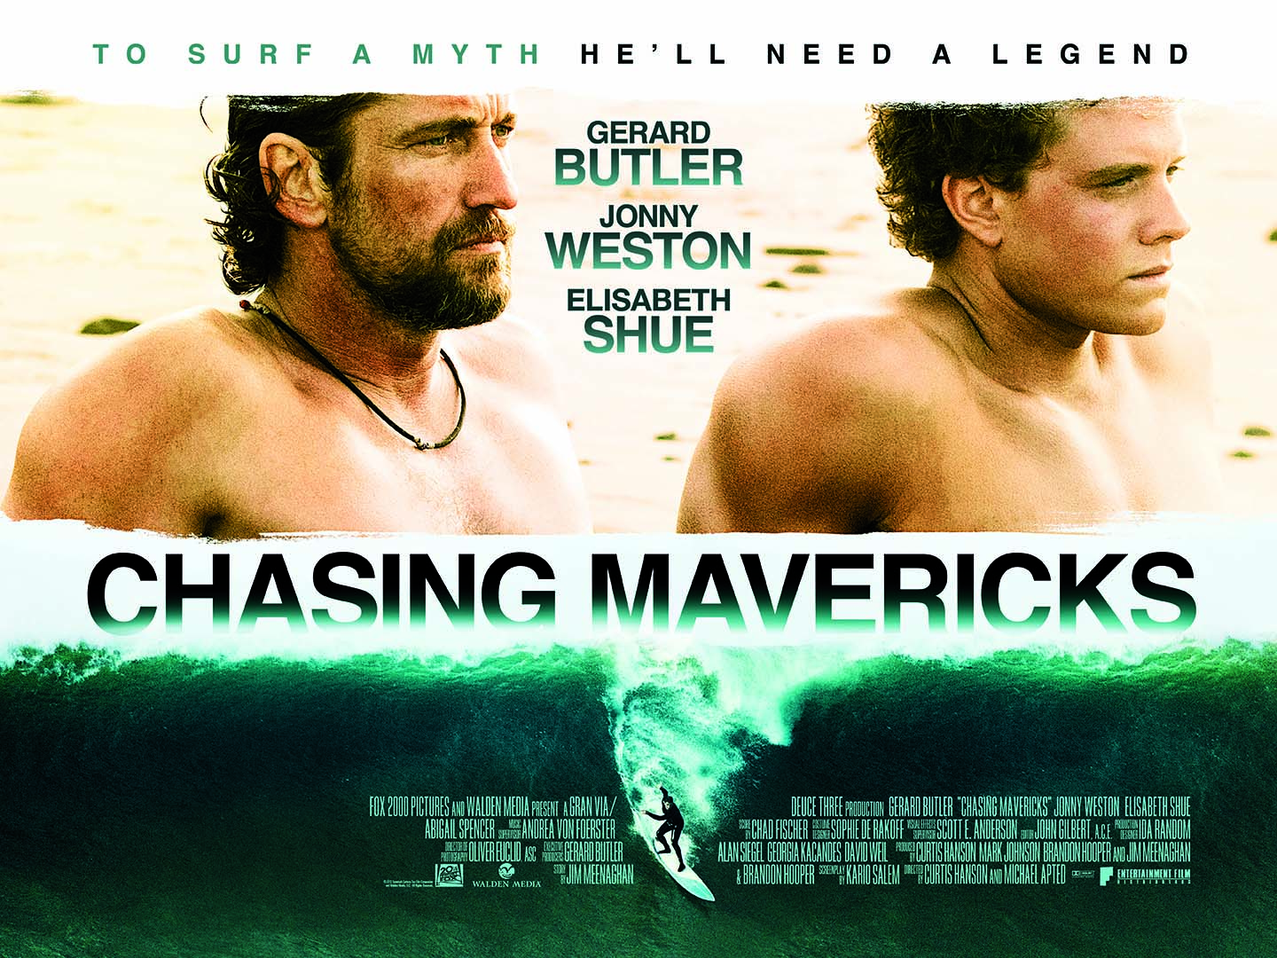
Gerard Butler, Elisabeth Shue and Hollywood newcomer Johnny Weston star in this inspiring true story of courage and friendship the whole family will love. When 15-year-old Jay Moriarity (Weston) discovers that the mythical Mavericks surf break is real, he reaches out to local surfing legend Frosty Hesson (Butler) to train him to ride it. What begins as a mentorship turns into a extraordinary bond that transforms both their lives, as Jay and Frosty learn valuable lessons about conquering fear in pursuit of your dreams. Featuring the most spectacular wave footage ever captured on film, Chasing Mavericks is packed with action and drenched with excitement!
Chasing Mavericks will be released by Entertainment in Video on DVD & Blu-Ray on
4th November 2013

JAY’S WORLD
Brandon Hooper and producer Jim Meenaghan – who together wrote the story – went directly to Frosty Hesson and Jay’s widow, Kim Moriarity, for permission to bring Jay and Frosty’s journey to the big screen. Other filmmakers had previously approached them, but Hooper and Meenaghan’s enthusiasm and ideas made Kim and Frosty comfortable with the idea of a film inspired by Jay’s life. Hooper notes, “Kim and Frosty have been supportive throughout the entire project, and we were grateful they entrusted us to tell the story. We wanted to do justice to them and, especially, to Jay.”
When director Curtis Hanson came on board the project, he joined Hooper and Meenaghan in Santa Cruz for scouting expeditions and research. “I met Frosty and Kim, and had long talks with them,” Hanson says. “We told them our film would resonate because everyone will identify with the struggles of these characters, and knowing that they’re based on real people will strengthen that identification and the emotional connections.”
Gerard Butler and Jonny Weston, like the producers and directors, immersed themselves in the world of Jay and Frosty. Weston shares, “I came to Santa Cruz and basically got adopted by Frosty and Kim and by some of Jay’s closest friends. They took me in and they told me everything they know about Jay.”
CHASING MAVERICKS was filmed on locations where much of Jay’s life unfolded, including Santa Cruz, Half Moon Bay and Mavericks itself, as well as residential streets where the real-life characters’ actual homes had been situated. “It’s beautiful that we were able to film where everything really happened,” says Butler. “It’s great for the story because it gives it an additional layer of verisimilitude.”

LIVE LIKE JAY
In addition to Frosty and Kim, many others who crossed paths with Jay participated in the film, including legendary surfboard shaper Bob Pearson, photographer Bob Barbour – and one thousand Santa Cruz locals who served as extras in a scene that reenacts Jay’s legendary triumph at Mavericks. The Santa Cruz community was thrilled to celebrate and share the legacy of “Live Like Jay.”
Hooper explains, “Ten years after Jay’s passing, there’s so much love still out there for him. These people did not turn out for the scene because this was a big Hollywood movie; they turned out for Jay.” Gerard Butler adds, “I’ve never heard people talk about anybody so positively as they did about Jay Moriarty. He touched people’s lives, had a kind word for everybody, and he affected an entire community. They all just wanted to be a part of that and were so proud that this story is being told.”
Weston adds, “Everybody recognized Jay’s purity and his selflessness. And whatever it was that made people love seeing Jay, whatever that energy he was putting out, people couldn’t really describe it. Everybody just knew what it meant.”
The filmmakers did not have to look far to find an impressive list of big wave surfers who wanted to participate in the making of CHASING MAVERICKS. In doing so, they paid tribute to an impressive legacy: When Jay had what was considered the biggest surfing wipeout to date and shortly thereafter rode the perfect wave; it changed the world of big wave surfing forever.

Cert – PG
Running Time
DVD - 111’41”
Blu-Ray - 116’28”

Cat Number Recommended Retail Price
Rental DVD EDR4253 £ N\A
Retail DVD EDV9734 £19.99
Blu-Ray EBR5213 £24.99
Special Features –
Featurettes
- Surf City
- Shooting Waves
- Live Like Jay
- Surfer Zen
Deleted Scenes-
- Frosty and Jay Paddle
- Jay Pays the Bills
- Power of Observation
- Where’s the Money
- Jay Laments
Audio Commentary
Theatrical Trailer

For further information please contact:
hayleyT@entertainment-film.com - Tel - 020 7930 7744

